Name: Max Gordon
Date: 3.25.2020
15.07 Picture Lab Worksheet
Directions: Make note of your responses to the following questions as you work through the activities and exercise in the lesson.
Activity 5 Questions
Question | Yes | No
- Is the method getPixels2D in the Picture.java class? |  | x
- Is the method getPixels2D in the SimplePicture.java class? | x
- Will the following code compile?  DigitalPicture p = new DigitalPicture(); |  | x
- Assuming a no-argument constructor exists for SimplePicture, will the following code compile?  DigitalPicture p = new SimplePicture(); | x
- Assuming a no-argument constructor exists for Picture, will the following code compile?  DigitalPicture p = new Picture(); | x
- Assuming a no-argument constructor exists for Picture, will the following code compile?  SimplePicture p = new Picture(); | x
- Assuming a no-argument constructor exists for SimplePicture, will the following code compile?  Picture p = new SimplePicture(); |  | x

Activity 5 Exercise Results

- Describe your method for keepOnly red, blue, or green.
I made other zero methods for each color and then I would just call like zeroGreen and zeroBlue for keepRed
- For the negate method, paste your code related to calculating and setting the values for red, blue, and green.
Pixel[][] pixels = this.getPixels2D();
for (Pixel[] rowArray : pixels) {
for (Pixel pixelObj : rowArray) {
pixelObj.setRed(255 - pixelObj.getRed());
pixelObj.setBlue(255 - pixelObj.getBlue());
pixelObj.setGreen(255 - pixelObj.getGreen());
}
}
- Paste a copy of the image that is the result of calling the grayscale.
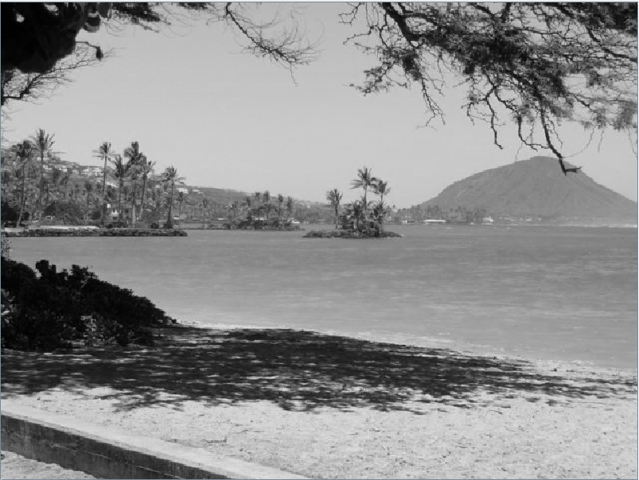
- For the method fixUnderwater, describe the algorithm you'd propose to accomplish the task.
The algorithm would use a ration to remove some of the blue and a little green

Activity 6 Exercise Results
- Paste the image that is the result of calling the method mirrorVerticalRightToLeft.
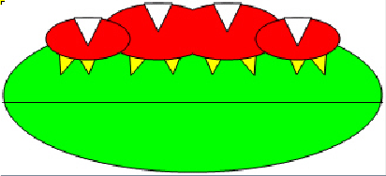
- Describe the algorithm for the method mirrorHorizontal works.
It takes the pixel values that are on the top half of the picture and copies them to the pixels that are directly reflected across a perfectly flat, horizontal middle line
- Paste the image that is the result of calling the method mirrorHorizontalBotToTop.

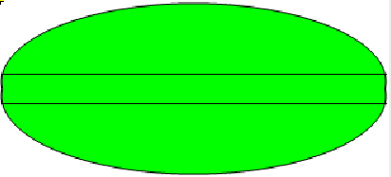
Activity 7 Questions
  - How many times would the body of this nested for loop execute? _90___
for(int row = 7; row < 17; row++)
for(int col = 6; col < 15; col++)
  - How many times would the body of this nested for loop execute? _112___
for(int row = 5; row <= 11; row++)
for(int col = 3; col <= 18; col++)

Activity 7 Exercise Results

- What value is displayed for count after the nested loop ends in the mirrorTemple method? _18410_
- Paste the image that is the result of calling the method mirrorArms.
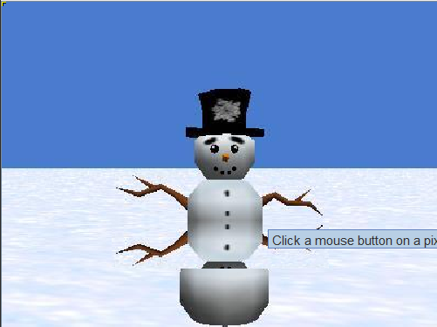
- Paste the image that is the result of calling the method mirrorGull.
